Data Analyst Intern

Learn To Build Real Time Twitter Analytics Dashboard - Power BI

**1. Introduction**

The report presents the analysis of tweet engagement metrics using Power BI. The goal was to explore user interactions with tweets based on various metrics like impressions, media views, and types of clicks (URL, profile, hashtag). Visualizations such as pie charts, scatter charts, and line charts were created to draw meaningful insights from the data.

**2. Background**

The dataset analyze consists of tweets, including impressions, media views, engagements, and click data. The analysis aims to uncover patterns in tweet interactions, focusing on the role of media content, time of posting, and specific engagement behaviors like URL clicks and hashtag interactions. The dataset includes tweets from various users and was analyzed to identify engagement trends.

**3. Learning Objectives**

* To analyze tweet engagement by visualizing different click types (URL, profile, and hashtag) in tweets with over 500 impressions.
* To investigate the relationship between media views and media engagements for tweets with more than 10 replies.
* To evaluate the average engagement rate for tweets with and without media content over time.

**4. Activities and Tasks**

* **Data Import**: Imported tweet data from a Excel file containing impressions, clicks, media views, and engagements.
* **Data Transformation**: Filtered tweets with more than 500 impressions, with odd tweet dates, and calculated engagement rates using DAX measures.
* **Visualization Creation**:
  + Developed a **Pie Chart** to show the proportion of URL, profile, and hashtag clicks for tweets with more than 500 impressions.
  + Built a **Scatter Chart** to analyze the relationship between media views and media engagements, highlighting tweets with an engagement rate greater than 5%.
  + Designed a **Line Chart** to track the trend of average engagement rates, separated by tweets with and without media content.
* **Time-Based Filtering**: Applied time filters to display specific charts only during designated hours (6 PM–11 PM IST, 3 PM–5 PM IST, and 7 AM–11 AM).

**5. Skills and Competencies**

* **Data Analysis**: Gained experience in transforming and filtering data using Power Query and DAX formulas.
* **Visualization**: Enhanced skills in creating and customizing Power BI visualizations like pie charts, scatter charts, and line charts.
* **Time-Based Filtering**: Learned how to use DAX and Power BI’s time slicers to filter data based on specific time intervals.
* **Problem-Solving**: Developed the ability to clean and preprocess data, including handling date and character count filters.

**6. Feedback and Evidence**

Feedback on the report highlighted the effective use of time-based filtering and the clarity of visualizations. The insights drawn from the data were considered valuable for understanding user engagement.

* **Pie Chart**: Proportions of different click types for tweets with more than 500 impressions
* **Scatter Chart**: Relationship between media views and engagements for tweets with more than 10 replies.
* **Line Chart**: Trend of average engagement rates for tweets with and without media content.

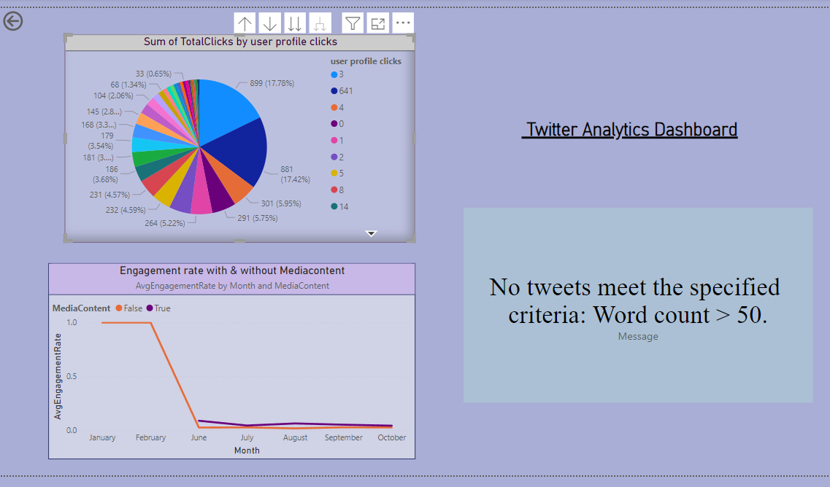

#### ****7.Challenges and Solutions****

* **Challenge**: Filtering tweets based on specific conditions, such as odd tweet dates and character counts.

**Solution**: Used DAX expressions like MOD() for filtering odd dates and LEN() for character count filters.

* **Challenge**: Applying time-based filters (e.g., only showing data between 6 PM–11 PM IST).

**Solution**: Created custom DAX measures to restrict data visibility based on the specified time intervals.

* **Challenge :** Filtering the tweet word count be above 50.

**Solution**: Placed a cardholder because no data meets the criteria, ensuring clarity

#### ****8. Outcomes and Impact****

1. The visualizations provided meaningful insights into tweet engagement behaviors. By analyzing the proportion of different click types, we identified that hashtag clicks played a major role in driving user engagement for tweets with high impressions. The scatter chart or placeholder is shown based on the data availability. The line chart demonstrated a clear trend in engagement rates for tweets with media content over time.These insights can guide social media managers to optimize their engagement strategies by understanding the best times to post and the types of content that resonate with users.

#### ****9. Conclusion****

In conclusion, this analysis provides valuable insights into tweet engagement, emphasizing the role of media content and the impact of timing on user interactions. The use of Power BI for visualizing and analyzing tweet metrics has enhanced my understanding of data visualization and DAX calculations. The findings offer practical guidance for improving social media engagement strategies.